**Git Stash then Git Apply**

Git Stash All and Keep Staged (–keep-index) :

The above git stash command will keep the changes on your working directory and also apply those changes to your git stash as well. This means that when you can switch to another branch and apply those changes. You can apply those changes multiple times to different branches.

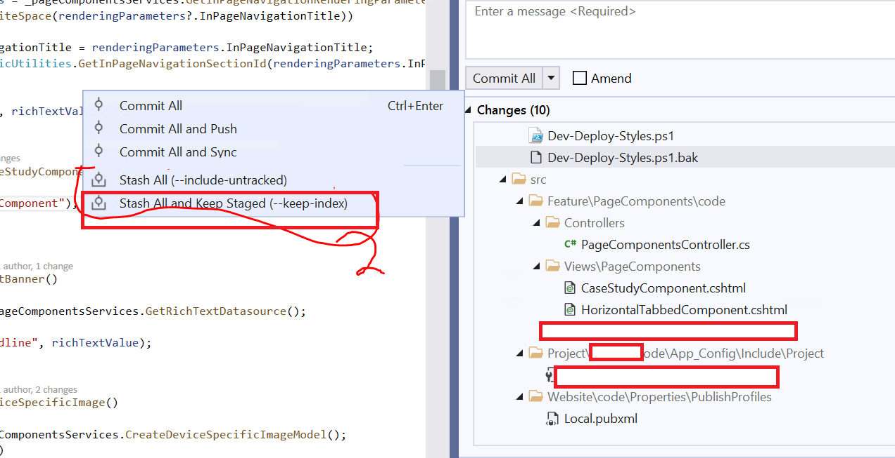

Apply All as unstaged:

Unstaged means that you have not git committed your changes.

After that you will need to upload the apply the stash to the same branch.

